1. Write a Java program to create a class called "Person" with a name and age attribute. Create two instances of the "Person" class, set their attributes using the constructor, and print their name and age.

Program:

public class Person {

private String name;

private int age;

public Person(String name, int age) {

this.name = name;

this.age = age;

}

public String getName() {

return name;

}

public int getAge() {

return age;

}

public static void main(String[] args) {

Person person1 = new Person("John", 25);

Person person2 = new Person("Jane", 30);

System.out.println("Person 1 - Name: " + person1.getName() + ", Age: " + person1.getAge());

System.out.println("Person 2 - Name: " + person2.getName() + ", Age: " + person2.getAge());

}

}

Output:

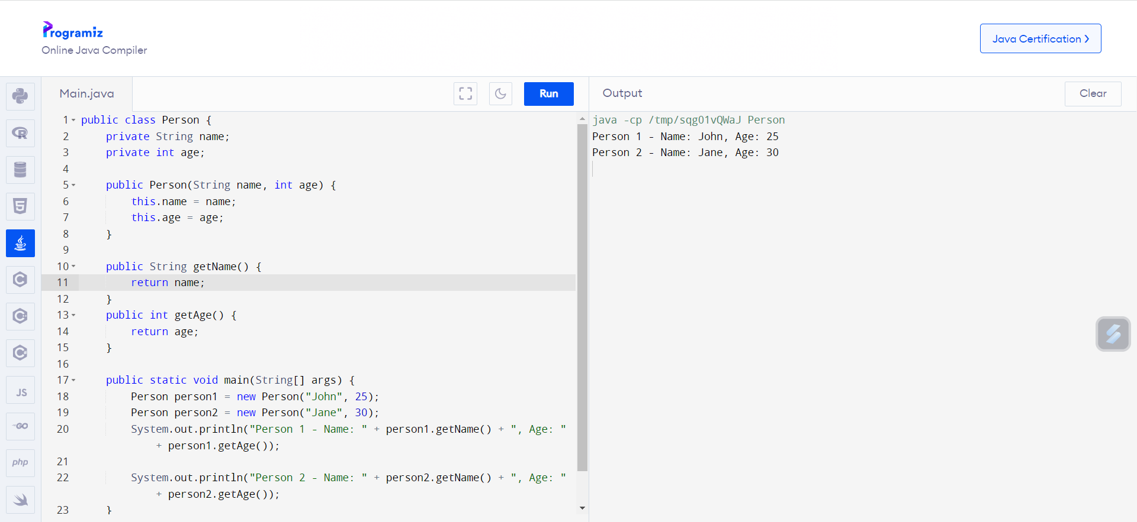

2.Write a Java program to create a class called "Dog" with a name and breed attribute. Create two instances of the "Dog" class, set their attributes using the constructor and modify the attributes using the setter methods and print the updated values.

Program:

public class Dog {

private String name;

private String breed;

public Dog(String name, String breed) {

this.name = name;

this.breed = breed;

}

public String getName() {

return name;

}

public void setName(String name) {

this.name = name;

}

public String getBreed() {

return breed;

}

public void setBreed(String breed) {

this.breed = breed;

}

public static void main(String[] args) {

Dog dog1 = new Dog("Buddy", "Labrador");

Dog dog2 = new Dog("Max", "German Shepherd");

System.out.println("Dog 1 - Name: " + dog1.getName() + ", Breed: " + dog1.getBreed());

System.out.println("Dog 2 - Name: " + dog2.getName() + ", Breed: " + dog2.getBreed());

dog1.setName("Charlie");

dog2.setBreed("Golden Retriever");

System.out.println("\nUpdated Information:");

System.out.println("Dog 1 - Name: " + dog1.getName() + ", Breed: " + dog1.getBreed());

System.out.println("Dog 2 - Name: " + dog2.getName() + ", Breed: " + dog2.getBreed());

}

}

Output:

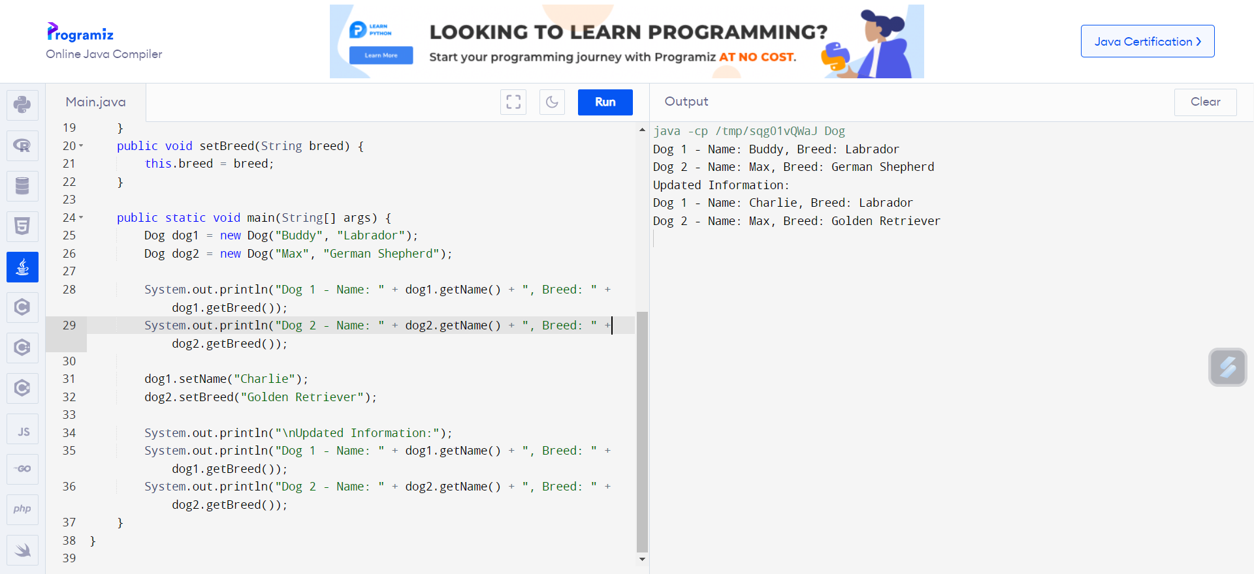

3. Write a Java program to create a class called Animal with a method called makeSound(). Create a subclass called Cat that overrides the makeSound() method to bark.

Program:

// AnimalTest.java

public class AnimalTest {

public static void main(String[] args) {

Animal genericAnimal = new Animal();

System.out.println("Animal Sound:");

genericAnimal.makeSound();

Cat cat = new Cat();

System.out.println("\nCat Sound:");

cat.makeSound();

}

}

class Animal {

public void makeSound() {

System.out.println("Generic animal sound");

}

}

class Cat extends Animal {

@Override

public void makeSound() {

System.out.println("Meow");

}

}

Output:

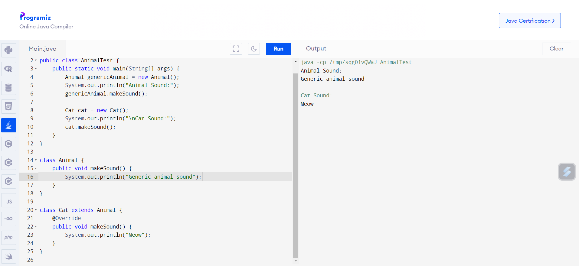

4.Write a Java program to create a class called Vehicle with a method called drive(). Create a subclass called Car that overrides the drive() method to print "Repairing a car”.

Program:

// Vehicle class

class Vehicle {

// Method to drive a vehicle

void drive() {

System.out.println("Driving a vehicle");

}

}

// Car class (subclass of Vehicle)

class Car extends Vehicle {

// Override the drive method to print a different message

@Override

void drive() {

System.out.println("Repairing a car");

}

}

// Main class for testing

public class Main {

public static void main(String[] args) {

// Create an instance of Vehicle

Vehicle vehicle = new Vehicle();

// Call the drive method of Vehicle

vehicle.drive(); // Output: Driving a vehicle

// Create an instance of Car

Car car = new Car();

// Call the drive method of Car

car.drive(); // Output: Repairing a car

}

}

Output:

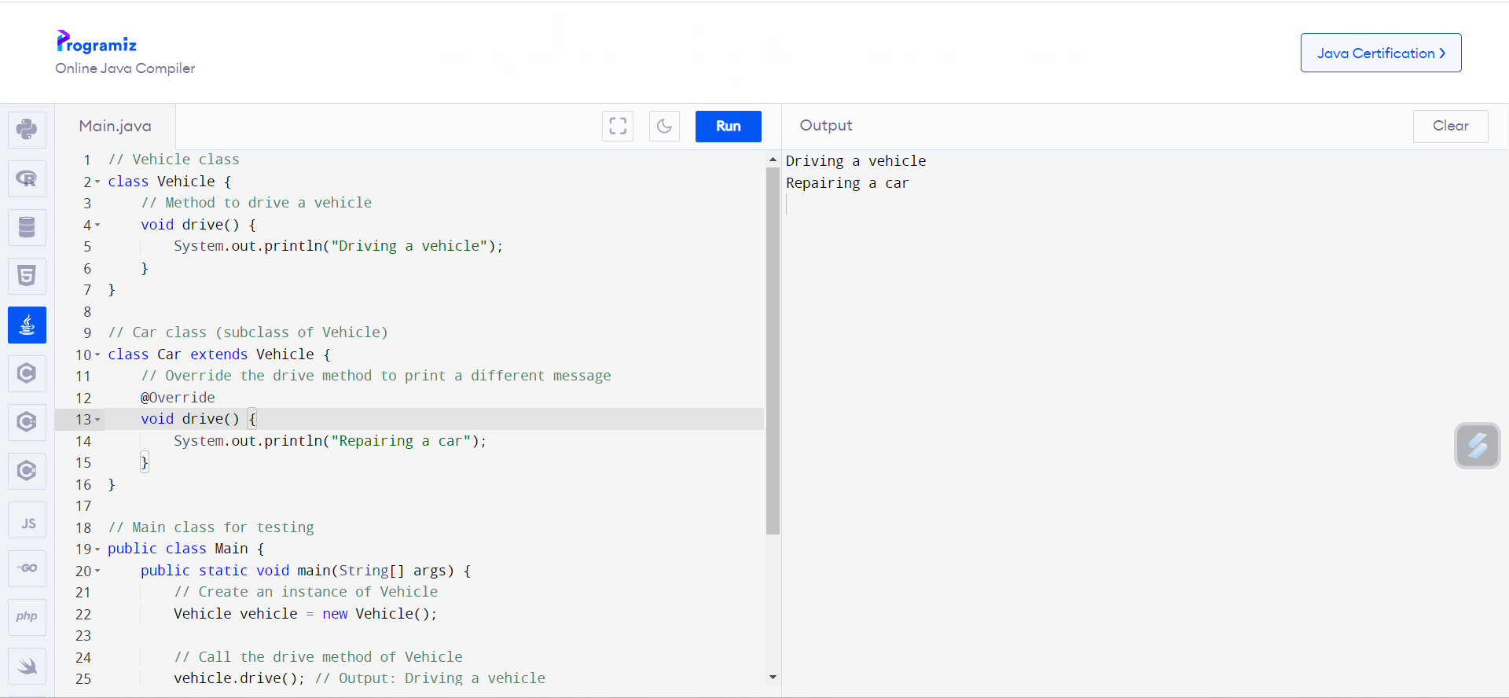

5. Write a Java program to create a class called Shape with a method called getArea(). Create a subclass called Rectangle that overrides the getArea() method to calculate the area of a rectangle.

Program:

class Shape {

double getArea() {

return 0.0;

}

}

class Rectangle extends Shape {

double width;

double height;

Rectangle(double width, double height) {

this.width = width;

this.height = height;

}

@Override

double getArea() {

return width \* height;

}

}

public class Main {

public static void main(String[] args) {

Rectangle rectangle = new Rectangle(5.0, 3.0);

double area = rectangle.getArea();

System.out.println("Area of the rectangle: " + area);

}

}

Output:

